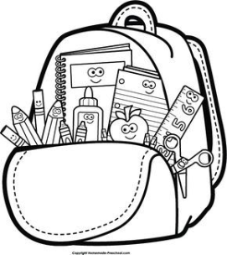
School Year 2022 - 2023
______________________________________________________________________________
1. NKJV Bible
2. Organizational Folder (to be purchased from teacher for $2.50)
3. Two Composition Notebooks (pages must be sewn in/no spiral notebooks please)
4. 1 box of 12 sharpened #2 pencils
5. 1 Small pencil sharpener
6. 2 Packs of big pink erasers
7. 2 Boxes of 24 crayons
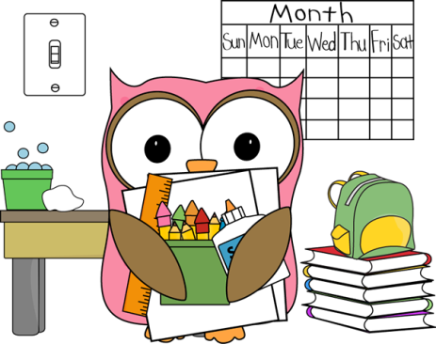
8. 2 Boxes of 12 colored pencils
9. Pencil/Crayon Pouch
10. 2 Pairs of scissors
11. 8 Glue sticks
12. 4 Expo Markers
13. 3 LARGE boxes of tissues
14. 2 Round containers of Wet Ones type hand wipes
15. 2 Containers of Clorox type surface wipes

