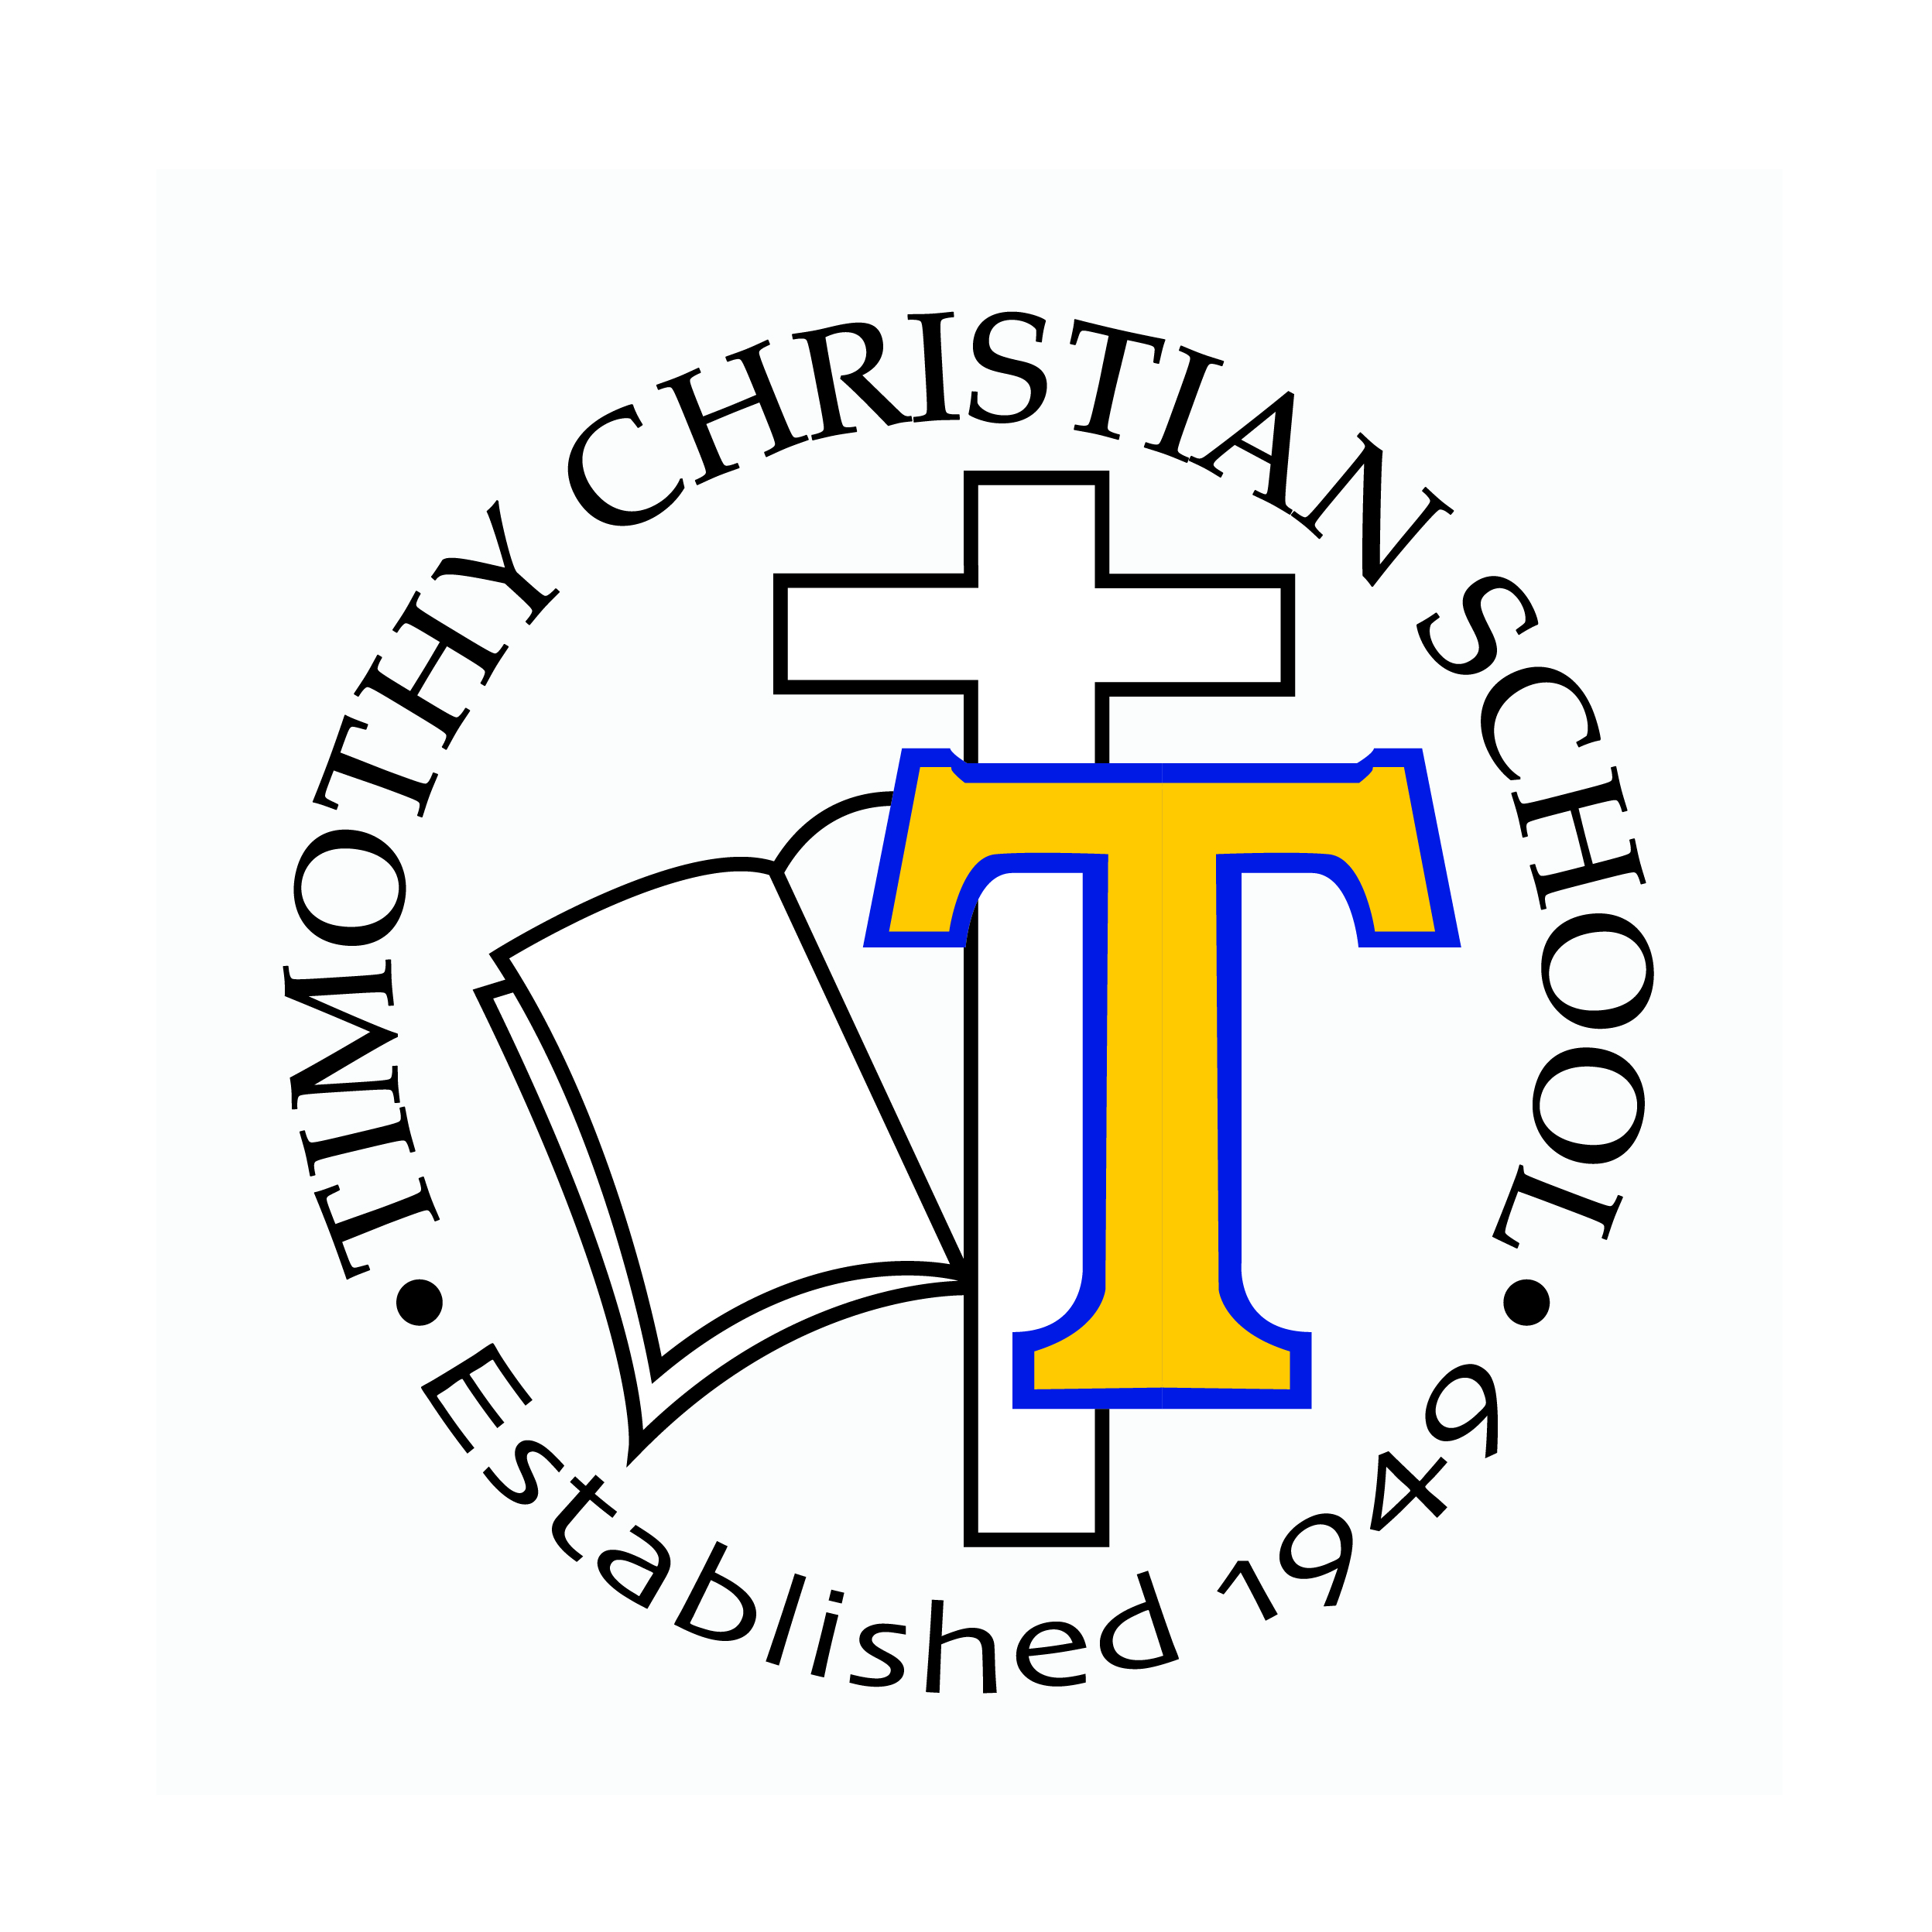
ONLINE LEARNING AT

Class Type | TCS Cost  (Does not include the cost of materials) | Comparison  (Does not include the cost of materials)
One-time Registration Fee | $30 | N/A
Standard Core/ Elective Course | $650 (Full)/$550 (Semester) | $650 (public school)  $1600 (Rutgers Prep)
Advanced Placement | $750/$650 | $800 (public school)  $950 (K-12 Online)
Dual Credit | $750 | $2460 (cost for an on campus, 3 credit class at Taylor University)
ELL (10 hours of 1 on 1 tutoring) | $850 | N/A
ELL – no tutoring | $250 | N/A
Course Recovery | $500 | $650 (public school)

